Result Analysis

Logistic regression for %Upsell_Revenue
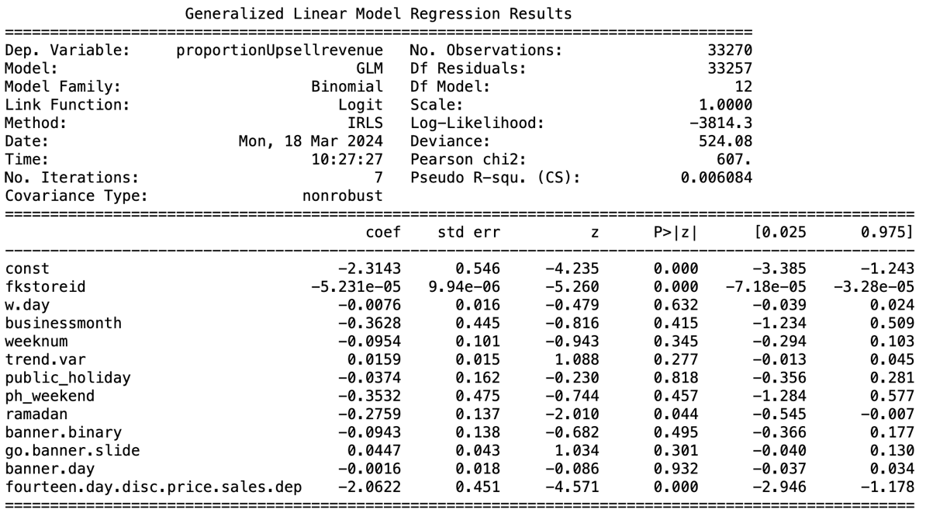

The coefficient for the independent variable ('fourteen.day.disc.price.sales.dep') is -0.2062. A negative relationship is demonstrated in this case, such that for every 10 percentage point increase in platform dependence, the proportion of sales revenue from upselling items shrinks by 18.63% ($1-e^{-0.2062}$). With a standard error of 0.451 and a z-value of -4.571, the p-value is less than 0.001, which indicates that the relationship is statistically significant at common significance levels.

Logistic regression for %Upsell_Order
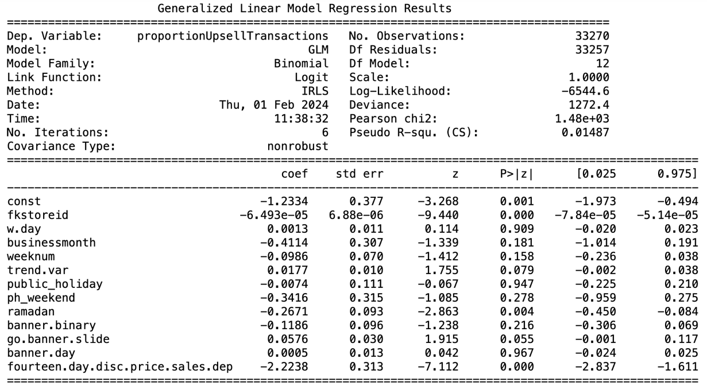

The coefficient for the independent variable ('fourteen.day.disc.price.sales.dep') is -0.2238. A negative relationship is demonstrated in this case, such that for every 10 percentage point increase in platform dependence, the proportion of sales revenue from upselling items shrinks by 20.05% ($1-e^{-0.2238}$). With a standard error of 0.313 and a z-value of -7.112, the p-value is less than 0.001, which indicates that the relationship is statistically significant at common significance levels.
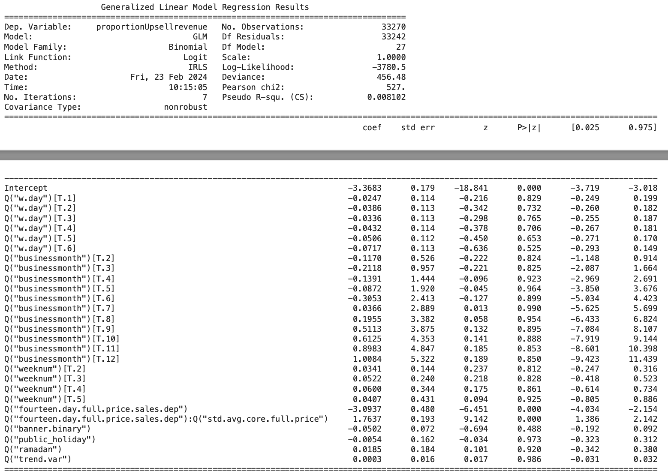

Moderation factor1 – Customers’ affluence level, measure by standard average sales revenue obtained per core menu item per order. The relationship coefficient is 1.7637, with p-value <0.001, the strong positive coefficient for the interaction term suggests that as the affluence increases, it has a positive moderating effect on the relationship between platform dependence and the proportion of upsell revenue. This implies that more affluent customers tend to significantly mitigate the negative impact that platform dependence might have on upselling.
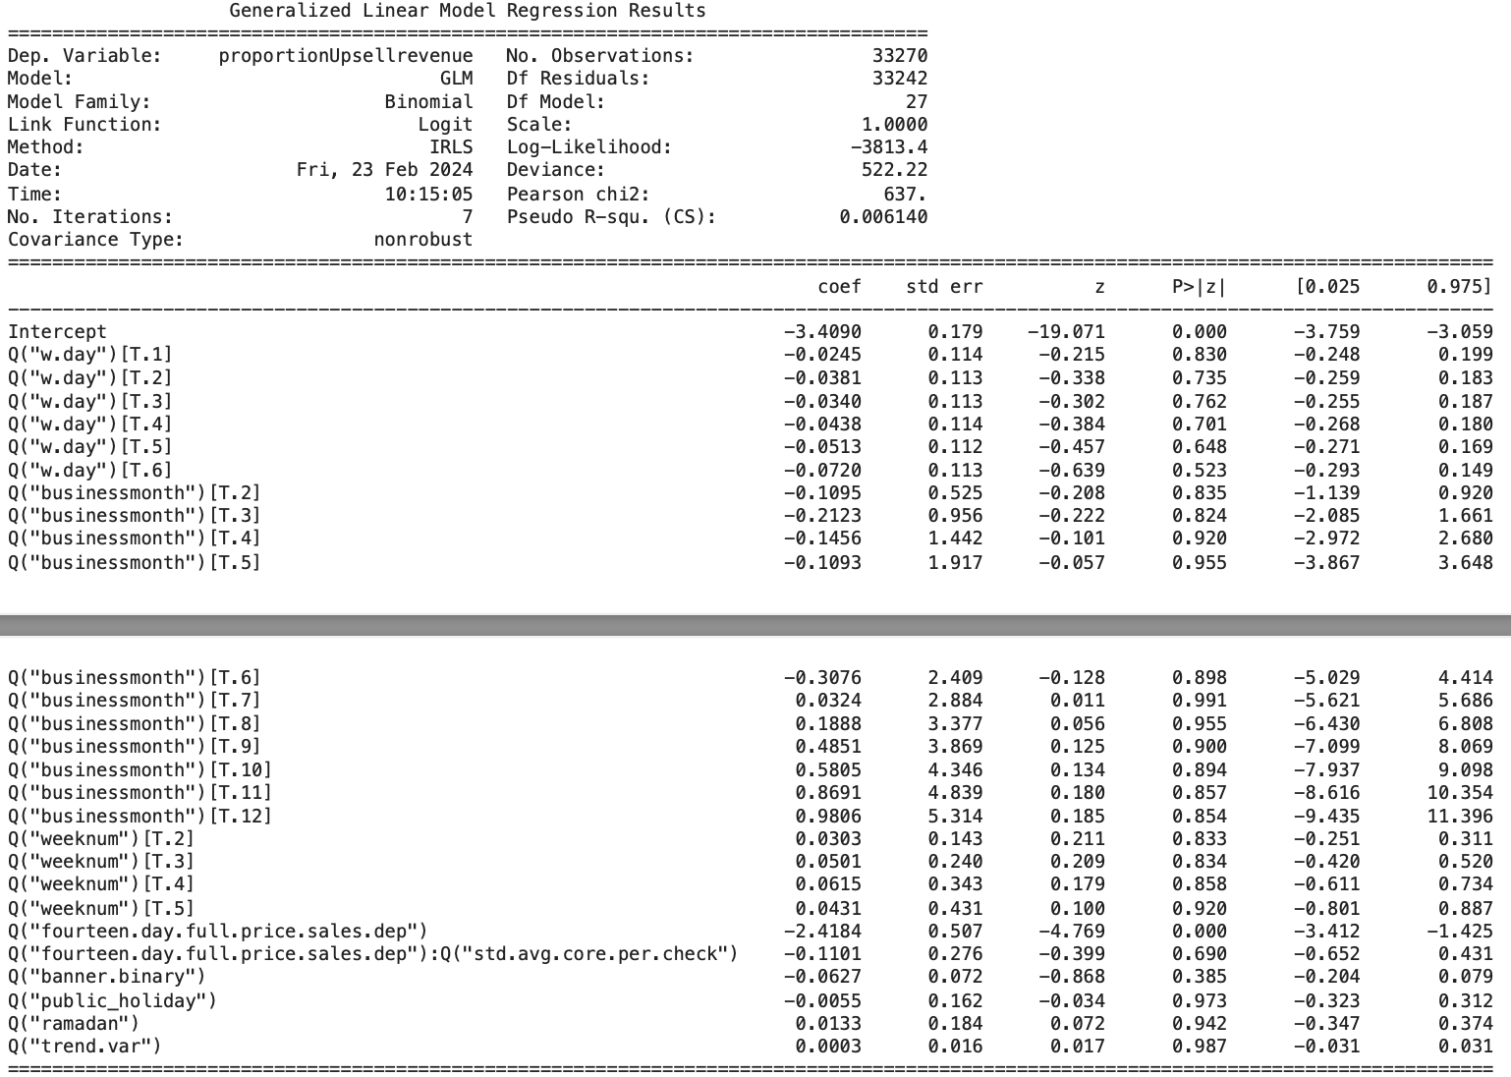
Moderation factor2 – Party size, measured by the mean number of core menu items ordered per check. The negative coefficient (-0.1101) suggests that as the party size increases, there is a decrease in the impact of platform dependence on the proportion of upsell revenue. However, the z-value and the p-value indicate that this effect is not statistically significant. A p-value of 0.69 is much higher than the typical alpha level of 0.05, which suggests that the observed coefficient is likely due to random chance. Therefore, with the given data, party size (measured by the mean number of core menu items ordered per check) does not significantly moderate the effect of platform dependence on upselling revenue in the restaurant industry, according to the statistical analysis from this GLM model.
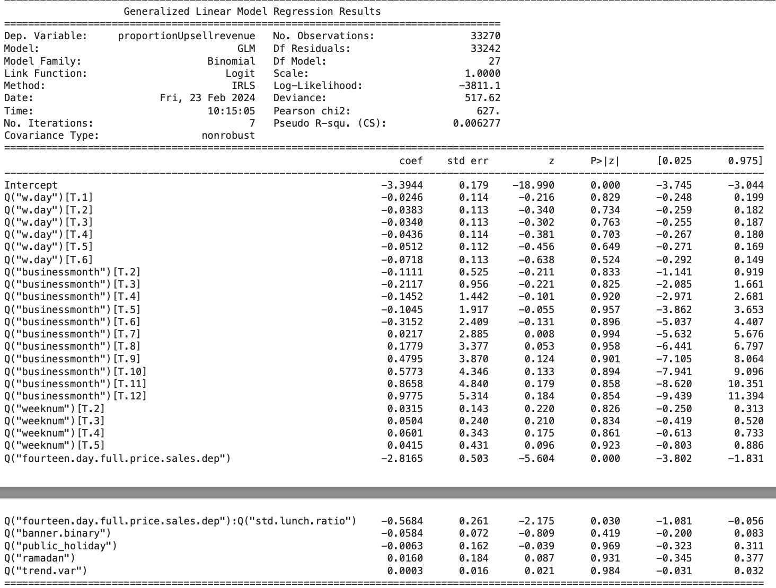

Moderation factor3 – Peak time distribution is defined as an indicator variable such that more meals are served at lunch than at dinner in a particular outlet. The relationship coefficient in this case is -0.5684 with p-value = 0.03, which suggests that the restaurants that are more popular during lunch peak than dinner peak will experience a larger drop in the percentage of sales revenue from upselling with the same dependence on online platform.

